1. **Scrum Project**

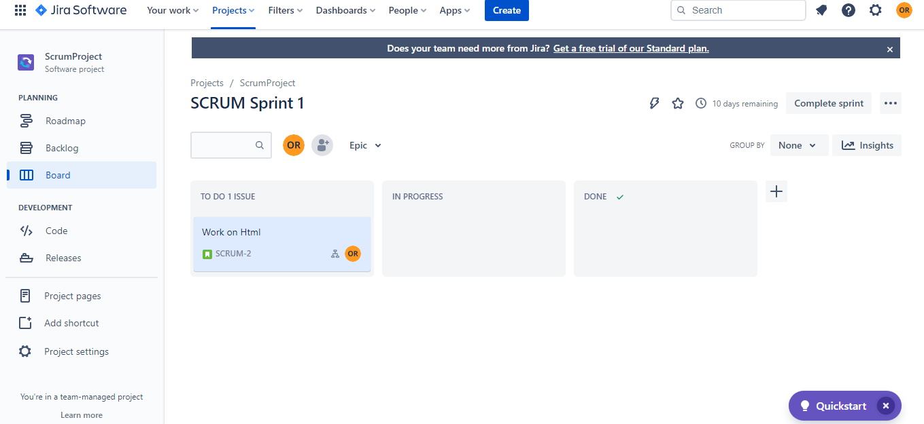

Work together using sprints to break down large, complex projects into bite-sized pieces of value

Organize cycles of work into sprints

Plan upcoming work in a backlog

**Kanban Project**

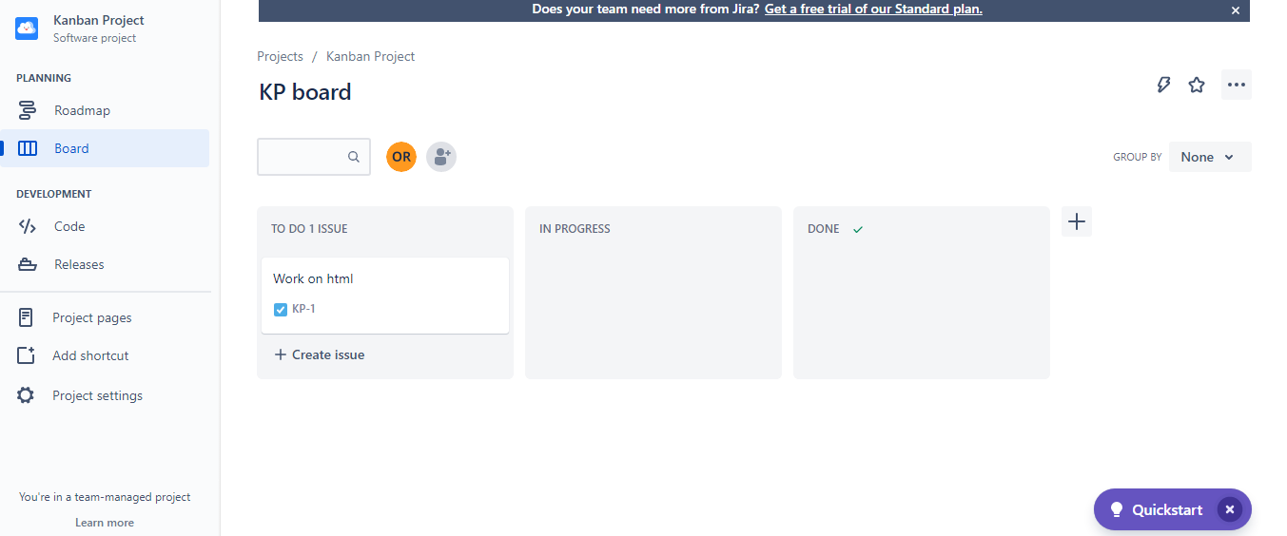

Help teams to visualize work.

Continuously improve with agile reports

**Bug Tracker**

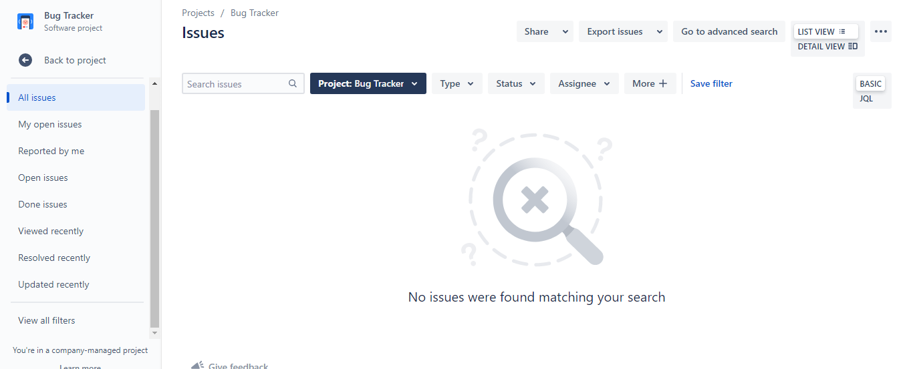

Identify and Capture Bugs

Assign and Prioritize bugs

**Project Management**

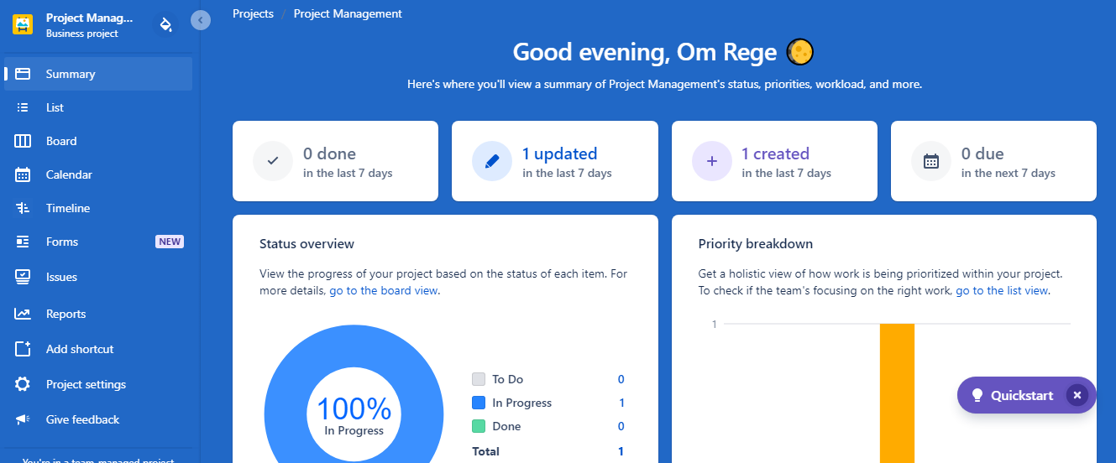

Summary view, priority items, workload,etc

Reports in the form of pie, line chart

Consolidate and Track work

**Task Tracking**

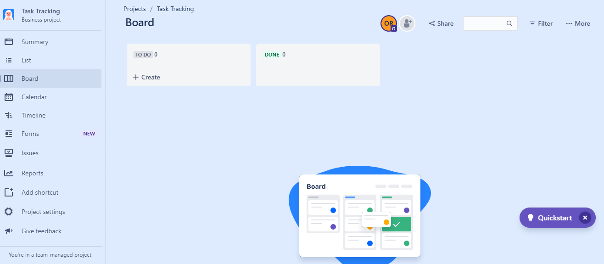

Board to track each piece of work from start to finish

Set start dates and due dates

**Process Control**

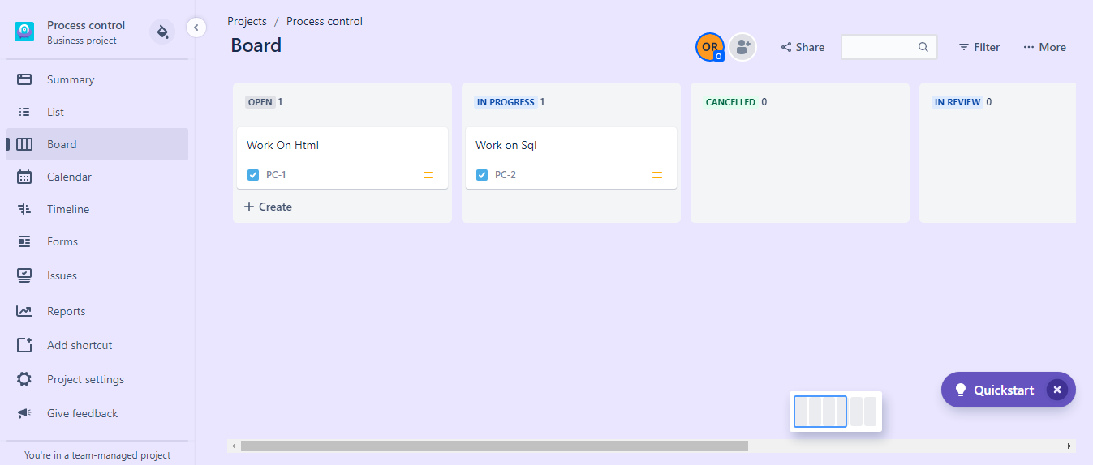

Board for visibility into where each process is at in your workflow and the list view to quickly make edits or add items as they come up

Add assignees.

**Content Management**

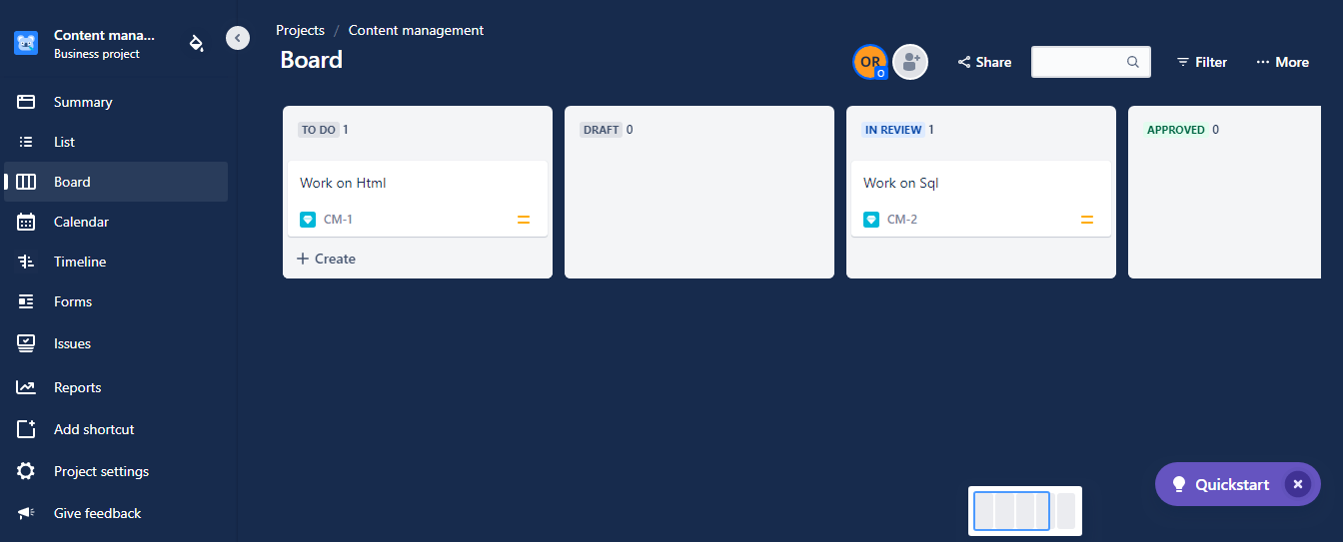

Track progress and get feedback along the way

Plan and prioritize your content needs

**Recruitment**

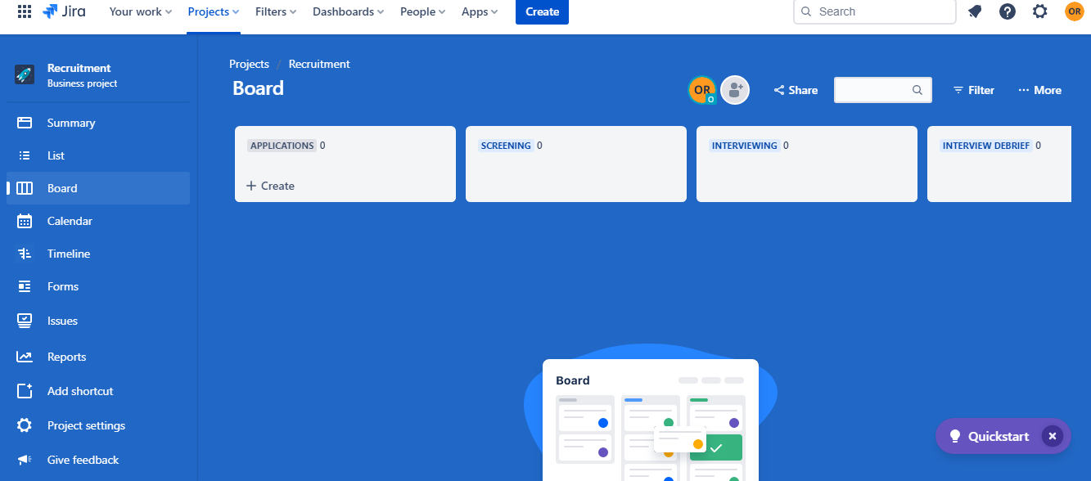

Capture your interview questions and feedback

Capture where a candidate is at each stage

**Document Approval**

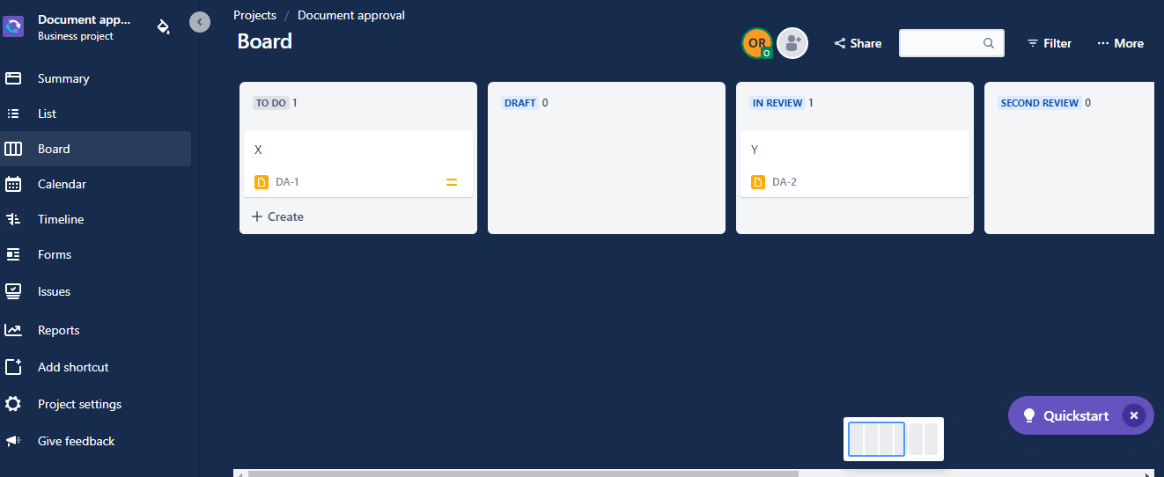

See all documents in a single view

View reports that show statistics for particular people, projects, versions, and data about your workflow

**Lead Tracking**

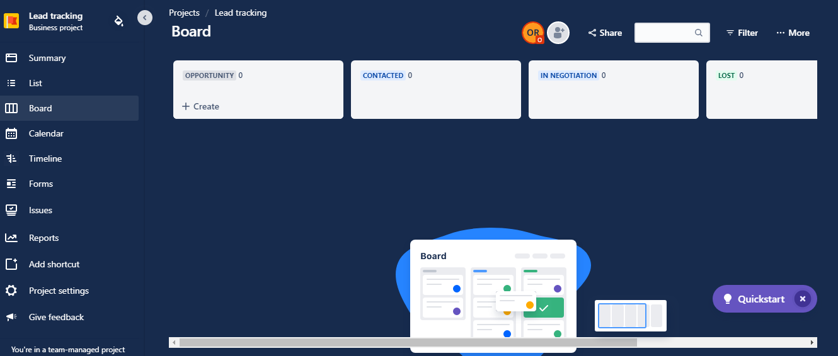

 Lead tracking template helps track sales deals from opportunity through to conversion.

Add and manage new leads

**Procurement**

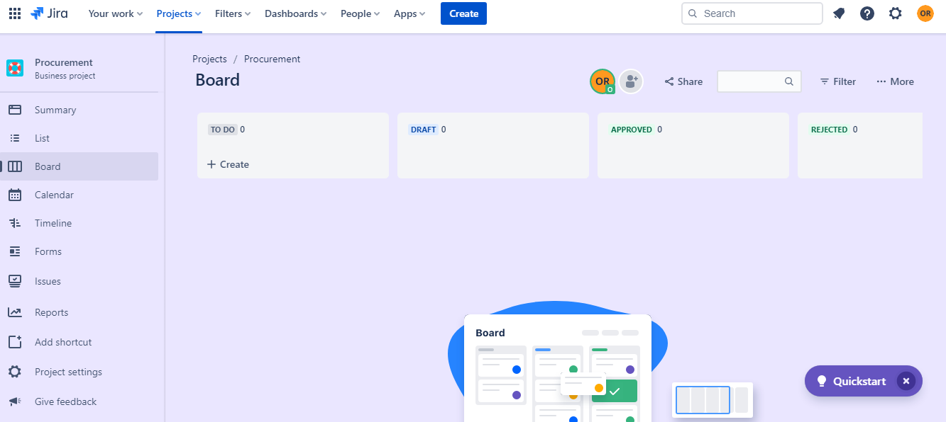

This template offers a simple way to track orders and ensure the proper approval process takes place

Visualize every request on the board.

1. **System event** — System events are used throughout Jira internally, and cannot be added or deleted. They can be made inactive

**Custom event** — Custom events are used to generate an email notification (or invoke a listener) from a particular workflow transition's post function. You can add and delete as many custom events as you need. Only *inactive* custom events can be deleted.

**Active state** — The event is associated with at least one notification scheme or workflow transition post function.

**Inactive state** — The event is not associated with any notification schemes or workflow transition post functions. The event state does not indicate whether the event is able to be fired. A custom event will only be fired if it is associated with a transition post function for an active workflow

1. In Project templates go to Service Management

Under Service Management go to General Service Management and create the project using this template

Go to Channels. Copy the email with address @defineagile.atlassian.net

Share this email-id to your team members and ask them to mail the issue on the same email id, with the issue defined on the subject of the mail.

Go to Queues in the Jira Dashboard

The issue sent via email will be automatically added.

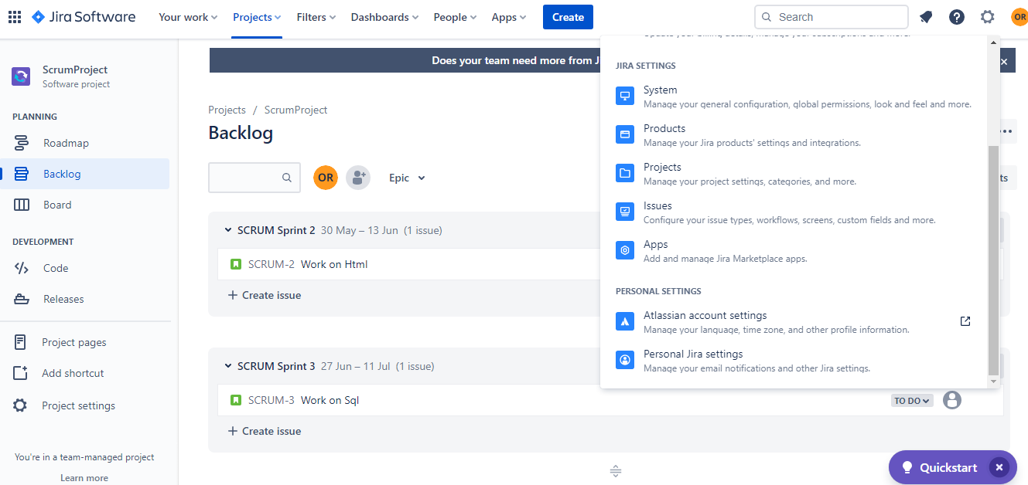

Go To Projects Under Settings

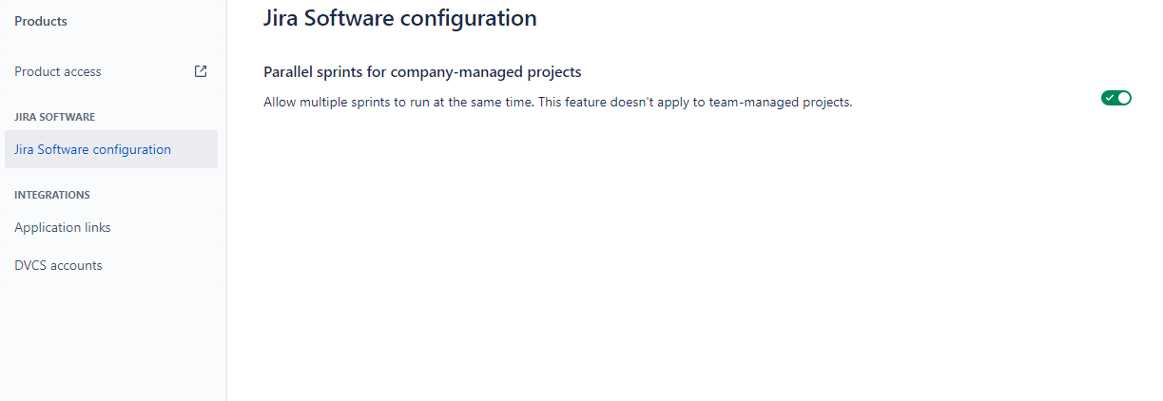

Under Jira Software configuration, check the option Parallel sprints for company-managed projects